Garhwal Post Dehradun, July 31, 2011
Use of IT mooted in XIIth Plan Group on Forestry
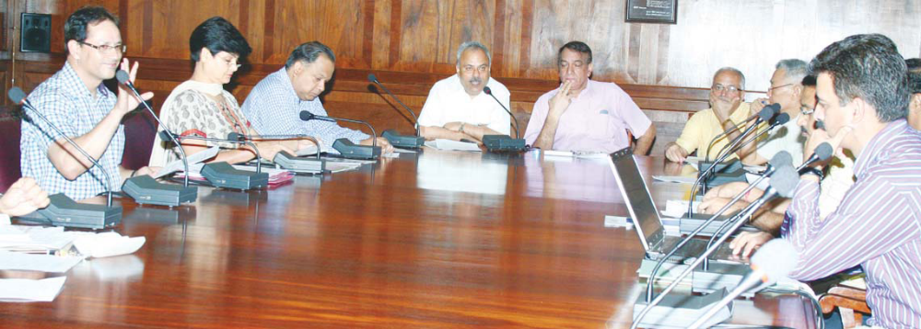

Various wings of Government of India are in the process of assessing the requirements under various sectors for the next five years, which will be reflected in the proposed schemes under the XIIth Plan Document. The Forestry Sector has constituted five subgroups under Working Groups on Forestry and Sustainable Natural Resource Management. An important sub-group has been
formed on Forestry Institutional and Technology Management which is headed by Director General, ICFRE, Dr VK Bahuguna. All important institutions in the field of forestry are integrated with this sub-group which includes ICFRE, IGNFA, FSI, WII, CASFOS, IIFM, IPIRTI, etc.

Experts from all these institutes are working on preparing the requirements in the forestry sector for the next five years. Apart from fulfilling the requirements of basic ongoing activities, many new initiatives are going to be incorporated in the next plan. All training of Forest Officers/staff is proposed to be brought under the one ambit of Director General (Training) with the apex scale and role of Director, IGNFA enhanced to hold this post. The other new innovative ideas include technological up-gradation of State Forest Departments, Forestry institutions and Forestry personnel. The rapid development in the sector of Information Technology necessitates building technological capacity of forest staff at all levels. Moreover, the technology should also be upgraded to the extent that the information flows in real time manner. That would assist in better management in the events of natural disasters, will assist in checking illegal activities in the forests and that would also enhance the morale of the personnel.

Proposals are also being made for development and up-gradation of infrastructure in all the states. New innovative schemes such as subsidised Food for Forest personnel; Group Insurance Cover and Mediclaim facilities for forest staff; Basic housing, education, medical and other facilities for families of forest staff; properly and adequately equipping the forest staff; strengthening manpower resources of forest departments of all states, etc., are on the anvil.

A meeting was organised at the Board Room of FRI today at which Director General, ICFRE, Dr VK Bahuguna, Director, IGNFA, Dr RD Jakati, Director General, FSI, AK Wahal, Director, FRI, Dr SS Negi, Principal, CASFOS, Savita and other experts from ICFRE, IGNFA, FSI, WII and DFE were present. The proposals were discussed and the group will finalise its report by 3 August and will make its presentation at MoEF, New Delhi. The new initiatives proposed in this plan will definitely provide a better environment for the working of all wings of forest departments and will help in conservation and better management of precious natural resources for which all are the custodians for the future generation.

